**Lennard Jones potential**

The Lennard-Jones potential (also referred to as the L-J potential, 6-12 potential, or 12-6 potential) is a mathematically simple model that approximates the interaction between a pair of neutral atoms or molecules. It is given by the equation

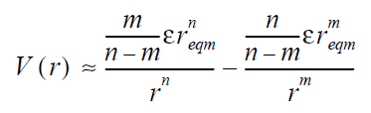

Where m=6 and n=12

Using the equations describing *C12* and *C6* ,

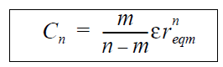,

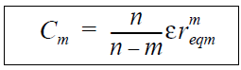

where  and  the energy and size parameters of the potential, respectively.

The following new set of 12-6 parameters were retrieved from autodock as shown in table1.

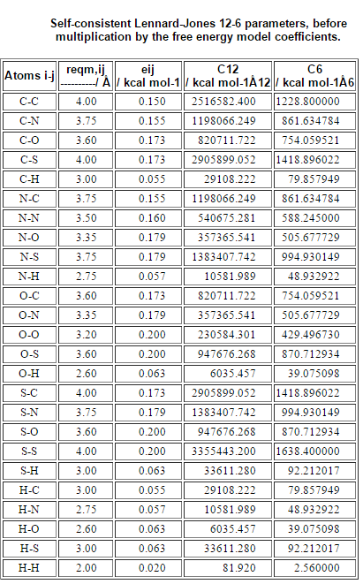

**Function for LJ\_potential:**

**Fe\_ LJ \_coefficient=0.1485**

**LJ\_ pot = [($∁12\text{/Rij)-2*(C6/} \text{Rij} \text{)}\text{]*} \text{Fe_} \text{LJ} \text{_} \text{coefficient}\text{.}$**

Where Rij is the distance between interacting atoms. The coefficients Aij and Bij are calculated from the well depths, , and equilibrium contact distances, reqm, of homogeneous pairs.

**Electrostatic Potential**

The electric potential energy of *q* in the potential of *Q*1 is given as,

U_E = \frac{1}{4\pi\varepsilon_0} \frac{q Q_1}{ r_1 }

where *ε*0 is the electric constant (permittivity of vacuum).

With reference to Autodock, the electrostatic grid is generated by **AutoGrid**, which solve the linearized Poisson-Boltzmann equation. Based on the work of Mehler and Solmajer, a sigmoidal distance-dependent dielectric function is given by

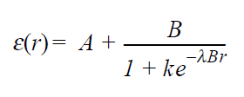

Where , ***B*** *=* *0 -* ***A***; *0* = the dielectric constant of bulk water at 25°C = 78.4; ***A***= -8.5525, ****   and ***k***= 7.7839 are parameters and **r** is the distance.

After calculating the dielectric function which is based on the relative distance, electrostatic potential energy is calculated using the above mentioned electrostatic potential equation

**EC \_ Potential** = **factor** \* **q1** \* **q2** / (******distance**)

Where **factor =332** # 4\*****\***0**\*units conversions.

**Function for  calcuation**

**** = 78.4 # dielectric constant of water at 25C

**lambda\_** = 0.003627 # supplied parameter

**A** = -8.5525 # supplied parameter

**k** = 7.7839 # supplied parameter

**B** = ** – A**

**** = **A** + **B** / (1.0 + **k**\*math.e\*\*(-**lambda\_\*B**\***distance**))

return ****.

**Function for electrostatic\_potential calculation**

If **distance**!=0:

return **(factor\*q1\*q2) / ( \*distance)** # kcal/mole

else: return 0

**Hydrogen bond energy**

A hydrogen bond occurs when two electronegative atoms, such as nitrogen and oxygen , interact with the same hydrogen. The hydrogen is normally covalently attached to one atom, the donor, but interacts electrostatically with the other, the acceptor. This interaction is due to the dipole between the electronegative atoms and the proton.

A distance cut-off for the interacting acceptor and donor atom is checked for < 4.0 Å. A check of angle between the (D-H···A) Donor atom-Hydrogen-Acceptor atom is done for the successful pairs (of the earlier condition). If the angle (Φ) is found to be greater than 140 degree, their energy is calculated. Hydrogen Bonding Energy is calculated using Lennard-Jones 10-12 Potential.

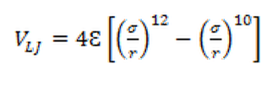

Where  and  refers to energy and size parameter.

**C12**= ij\* (**reqm, ij**) **12** and **C10= ij\*(reqm, ij) 10** parameters required for the above equations are derived from autoadock and is shown below in the table 2 as follows.

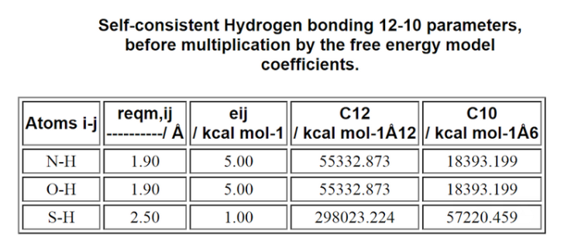

** Interactions:**

π-π interactions are caused by intermolecular overlapping of p-orbitals in π-conjugated systems, so they become stronger as the number of π-electrons increases. π- π stacking occurs when two aromatic rings are located parallel to each other at a distance less than 7.0Å. The list consisting of aromatic rings for protein and ligand are derived and distance between the centroids of the ring of each ligand with all the rings in the protein are computed. If the distance threshold is met, angle between the normal of two planes are computed  and If the angle of the normal is approximated to be within the prescribed range of (i.e. 0 to <30o or 180oto >150o), Vander waal force of interaction and the electrostatic force is calculated for all the atom pairs making a one-to-many combinations.

The Vander waal force is approximated using Lennard Jones equation:



Electrostatic potential is calculated using,



**Cation- Interaction:**

Cation–π interaction is a [noncovalent](http://en.wikipedia.org/wiki/Noncovalent" \o "Noncovalent) [molecular interaction](http://en.wikipedia.org/wiki/Chemical_bond) between the face of an electron-rich [π system](http://en.wikipedia.org/wiki/Aromaticity) and an adjacent [cation](http://en.wikipedia.org/wiki/Cation" \o "Cation). The cation  interaction arises from the electrostatic interaction of a cation with the face a  system. Cation-π interactions were identified according to a distance and an angle criterion. The distance criterion required that at least one of the atoms of the aromatic ring be

located no further than 4.5 Å from one of the atoms carrying the positive charge. The angle criterion demanded the latter atom to be situated above the plane defined by the aromatic ring, more precisely, inside a cylinder of height 4.5 Å, whose base included the ring and had a radius

equal to the ring diameter. Similar, to the energy calculation in  system, cation-  interaction energy is calculated using electrostatic and vander Waals energy.

**Desolvation energy term:**

Solvation free energy serves as a characteristic property of various molecules in material, biological, and pharmaceutical sciences. For example, the knowledge of solvation free energy is prerequisite for the determination of the equilibrium constant for protein-ligand association because the desolvation costs for complexation can make a significant contribution to the total binding free energy.

With reference to autodock, the equation for calculating the free energy change upon binding of a ligand to a receptor, ΔGdesolv is given as

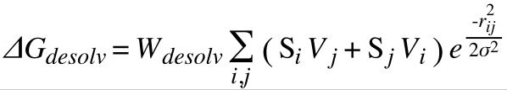

Where,

i= index of atoms in the ligand.

j= index of atoms in the receptor.

Wdesolv = linear regression coefficient or weight for the desolvation free energy term

Si= salvation term for atom i

Vi = atomic fragemental volume of atom i

Rij = distance between atom I and atom j in angstrom.

  Gaussian distance constant = 3.5 angstrom.

The solvation term for atom i depends on the partial atomic charge of atom i, qi:



Substituting in free ΔGdesolv, we can calculate a desolvation map, ΔGdesolv, ligmap, that will give the appropriate contribution for the desolvation free energy, ΔGdesolv, lig, when we know the partial atomic charge on the ligand atom, qi, at the docking stage:

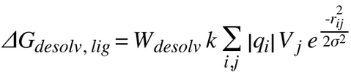

Where,

Ai= atomic solvating parameter, ASP, for atom i, where

Type ASP std. error

C -.00143 0.00019

A -.00052 0.00012

N -.00162 0.00182

O -.00251 0.00189

H -.00051 0.00052

S -.00214 0.00118

k = charge-based atomic salvation parameter, QASP = 0.01097 (std. error = .00263)

qi = partial atomic charge on atom i.